A THOUGHT FOR THE WEEK – Cradle Roll 3rd May 2020

It‘s always a great privilege to welcome people into the family of God in Baptism – young and older - and it’s the same for us at Cooksmill Green.

Most of our congregation will know much of what I’m about to write, but for those visiting our website who may not know us so well, I thought it would be a good idea to let you know what we do. It’s also a useful reminder for the rest of us!

Whenever we baptise a child in our chapel, during the course of the service we pray that child will grow in faith in Christ and that in adulthood they’ll make a conscious decision to become part of the membership of God’s church, wherever they may be. In addition to the promises made by parents and Godparents to guide the child on this journey, the church congregational also makes a promise:

‘Will you endeavour to maintain here, a fellowship of worship and service in the Church, that this child may have the opportunity to grow in the knowledge of God and his son Jesus Christ our Lord.

And the church replies

With God’s help we will
Implicit, is not only the promise to ensure access to worship in a safe and loving environment for the young people as they grow (more of that in a moment) but also to remember them in our prayers - and all those who have been previously been baptised. The truth is that can be easy to say, but we all know how life’s pressure can crowd out such promises. So once a year we make a special effort to keep our promise and this year, today is the day, our ‘Cradle Roll’, but not of course, how we normally do it. And perhaps this year we can remember all children and young people everywhere, baptised or not, praying for their future in this ever changing world.

The names of all those baptised are written into our Cradle Roll Book. At the service the names of those added in the last few years are read out loud and we ask God to bless each and every one of them. This year we can’t do it quite the same, but I ask you to remember all these people in your prayers today, knowing that the book has been placed on the alter table in the chapel next to a lighted candle and that God loves each one – and all of us.

I mentioned access to worship for the youngsters, well, we have a wonderful team of members and helpers who run what we call ‘Sunday’s Cool’. Here they learn the stories of the bible in a safe loving environment and have the opportunity to share their youth and enthusiasm with the whole church. See the Sundays Cool tab at www.cooksmillgreenchurch.org

Luke 18: 15-17 NRSV
¹⁵ People were bringing even infants to him that he might touch them; and when the disciples saw it, they sternly ordered them not to do it. ¹⁶ But Jesus called for them and said, “Let the little children come to me, and do not stop them; for it is to such as these that the kingdom of God belongs. ¹⁷ Truly I tell you, whoever does not receive the kingdom of God as a little child will never enter it.”

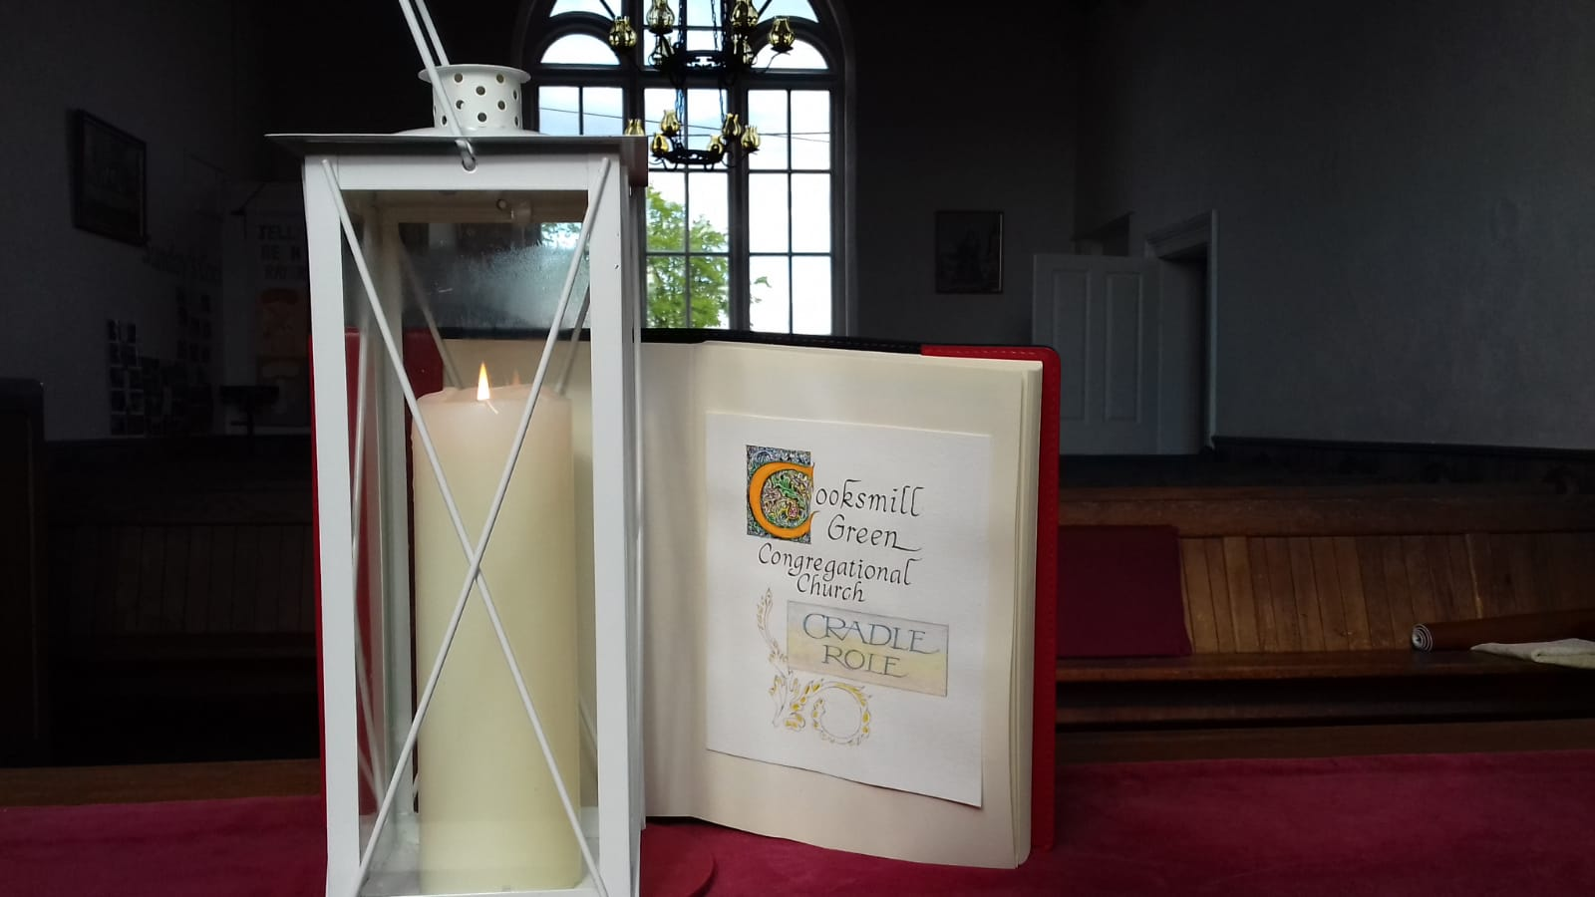

This week, time has been taken out to remember those whose have died during this Covid-19 crisis, so today we have two prayers. One, to keep our promise above, the other to remember - closing with words from St Augustine, often used for the sick and dying.

Heavenly Father
We have promised always to
Remember and uphold those
Baptised into your church.
And we do so now.

We pray for each and every name
In our Cradle Roll Book,
Confident they are in your hands.
Lord we pray that each one
Will come to know you in a very special way
That they will know your love throughout their lives
And come to put their faith in You.

For those who have grown to maturity
And faith, may they also know
And feel your love today.
Give them and us strength to
Follow and serve you
All the days of our lives.
As we make this prayer to you
We pray for the future of all children
And young people in our world today,
In all its uncertainties.

And finally

Loving Father we remember those who have
Lost their lives during this difficult time.
And in the words of St Augustine
We pray for those who are suffering still:

Watch, O Lord, with those who wake,
Or watch, or weep tonight,
And give your angels charge over those who sleep.
Tend your sick ones, O Lord Christ.
Rest your weary ones.
Bless your dying ones.
Soothe your suffering ones.
Pity your afflicted ones.
Shield your joyous ones.
And for all your love's sake. Amen.

(St. Augustine 396 – 430)

